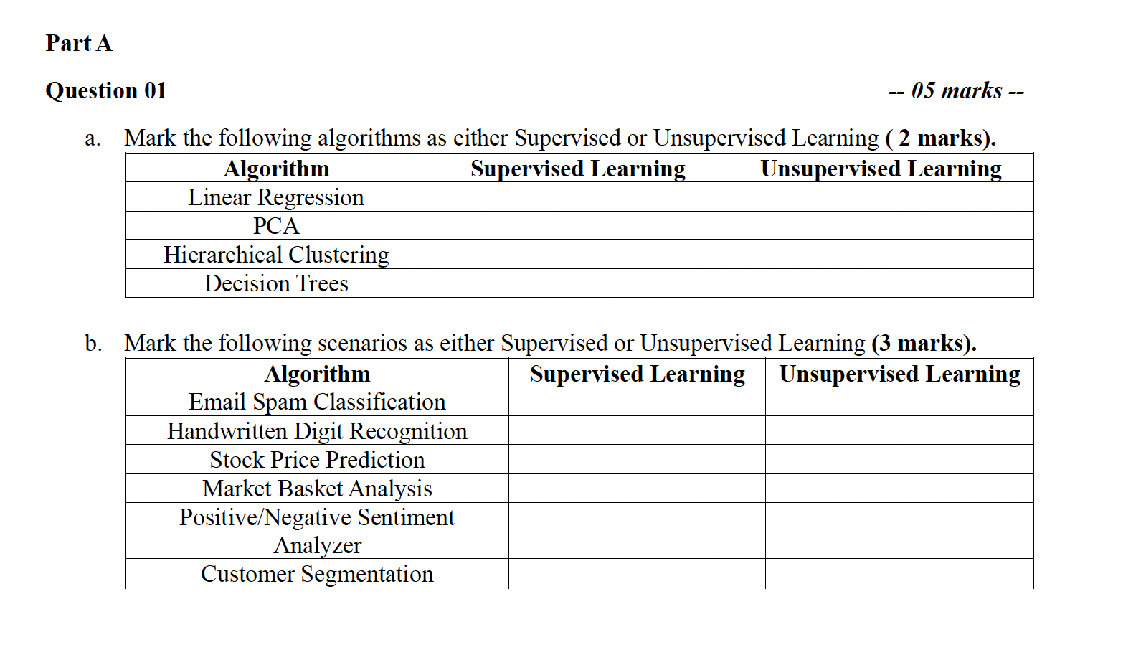

1. Briefly discuss the terms “Classification”, “Regression” and “Clustering” in terms of similarities and differences among them. *(3 Marks)*
2. “Interpretability” or “Explainability” is one of the main challenges while building machine learning models. Explain the term “interpretability” in the context of machine learning models *(1 Mark)* and give examples for interpretable models and non-interpretable models. *(2 Marks).* Also give a real-life scenario where interpretability is more important than just achieving a higher accuracy. *(1 Mark)*
3. Explain why data normalization is important before feeding the data into the machine learning model *(2 Marks).* Discuss two normalization techniques briefly *(2 Marks).* Someone argues normalization is not needed while using complex models like neural networks. Give one fact that justifies this argument and one fact against it. *(2 Marks)*